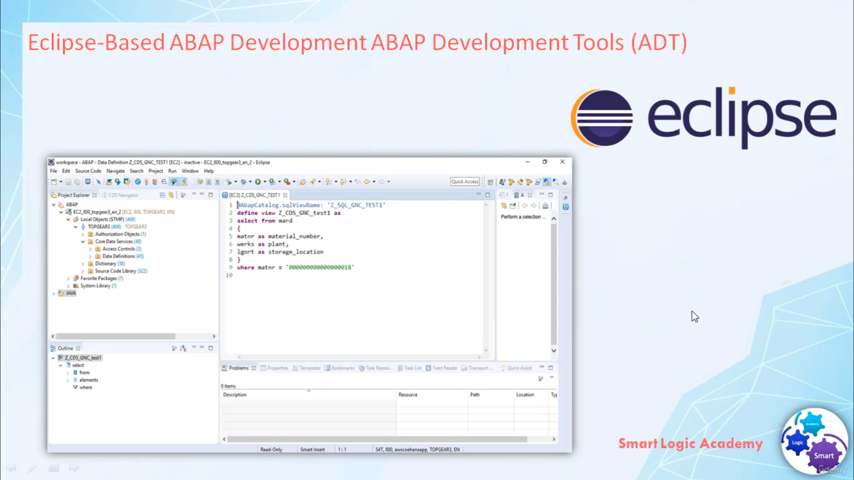

Now you know, for editing new repository object you can't use ABAP workbench. For editing the new repository

object

you required ECLIPSE base ABAP development tool.

ADT is alternative to ABAP workbench

and it provides various features.

ABAP Development Tool (ADT) is a complete new ABAP development experience on the top of ECLIPSE platform.

ADT provides an open platform for developing new ABAP related tools.

ADT is a set of open, language-independent and platform-independent APIs that developer can use to build

new custom tools for ABAP environment.

ADT ABAP Development Tool enables cross-platform development by integrating ABAP and non ABAP development

tools in a single powerful integrated development environment.

When you used the ABAP development tool, you log on to SAP backend system and work directly with repository

objects.